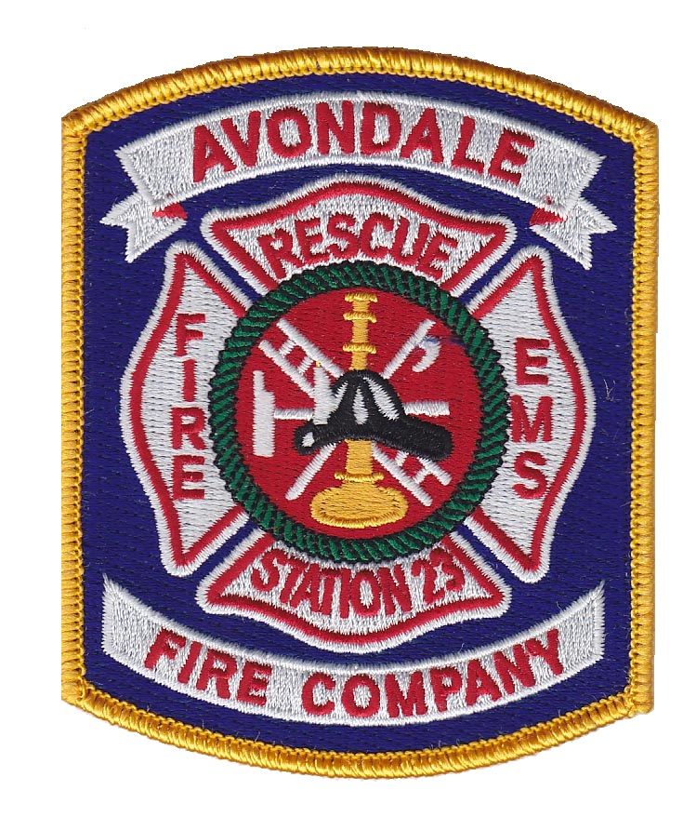

**CONTACT:**

[golf@afc23.org](mailto:golf@afc23.org)

**\* Mailing Address**

ATTN: Golf Tournament

23 Fire House Way

Avondale, PA 19311

* Send Entry Forms &

payment to this address

# 2019 AVONDALE FIRE COMPANY

# GOLF TOURNAMENT ENTRY FORM

**DATE: May 13, 2019**

**TIME: Registration at 8:00 AM. Shotgun start at 9:00AM**

**PLACE: Hartefeld National Golf Club**

**1 Hartefeld Drive**

**Avondale, PA 19311**

**Entry Fee:** Early Registration - $100/Player before 4/29/19

Late Registration - $110/Player after 4/29/19

(Green Fees, Cart & Catered Lunch included with registration)

**Format:** Tournament will be played in Scramble with 4-person teams. If you do not enter a team list, you will be placed with others**.**

**Cancellation Policy:** If player is a “no-show”, entry fee is non-refundable.

**Entry/Sponsor Form:**

NAME: __________________________________________

COMPANY: __________________________________________

ADDRESS: __________________________________________

__________________________________________

TELEPHONE: __________________________________________

EMAIL: __________________________________________

**Team Members:**

Player Name: ____________________________________

Player Name: ____________________________________

Player Name: ____________________________________

Player Name: ____________________________________

**Sponsorship Options:**

☐ Program Sponsor $100 (name of business in the program banner)☐ Hole Sponsor $250 (sign at hole and program banner)

☐ Putting Green $300 (sign at putting green and program banner)

☐ Closest to the pin $500 (sign at hole, program banner)

☐ Longest Drive $500 (sign at hole and program banner)

☐ Special Hole (TBD) $500 (sign at hole and program banner)

☐ Course/Event Sponsor $1000 (cart signs, hole sign, program banner)  
☐ Other donation amount $________